Certificate: Information Technology: Systems Development (Web Development 2)

PROGRAMMING (GPG522)

Project 3

Theme:

Hand out: 10/18/2018

Hand in: 10/26/2018

Section A [9]

Select from list

Question 1 [5]

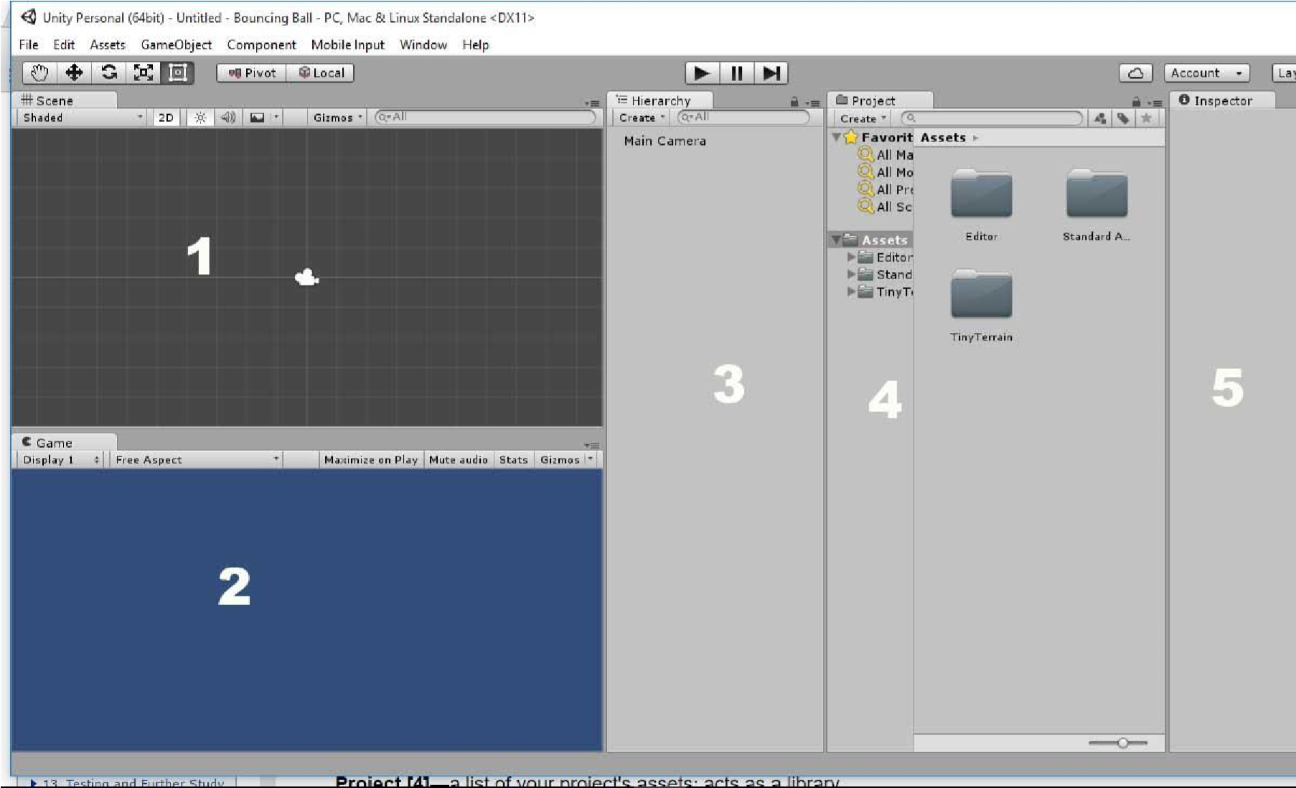

Given the diagram above, identify the numbered labels above.

1. ___________Scene______ Answer: 1
2. ______Game__________ Answer: 2
3. _____hierarchy________________ Answer: 3
4. _________project__________ Answer: 4
5. __________Inspector___________ Answer: 5

Question 2 [4]



Identify the symbols in the diagram above

* 1. ______Hand tool_____ Answer: A
  2. _____translate tool_______ Answer: B
  3. _____Rotatate tool_______ Answer: C
  4. _____Scale tool______ Answer: D

Section B[65]

Long questions

Question 1[5]

Differentiate between local space and world space.

Answer:

World space is the space relative to the origin point of the map and local space is the area around the player.

Question 2[5]

An object A in the game world is located at the coordinate (4, 5). It then moves (7,4) relative to its original position. Showing your calculations, what position is object A?

Answer: (4+7,5+4)=(11,9)

A(11,9)

**Question 3[20]**

**Define the following**

* Assets: anything or item usable in the project like all the different files in the Asset folder
* Prefabs: These are Objects in the game already configured and combining assets together.
* Scripts: The is the logical code that supplies function to game objects in the game.
* Collider: This is a grid assigned to game objects to make it solid so other objects can pass through it or it can be used to set up a trigger which is used to set up and event or is used in code in statements.
* Scenes: This contains your set up scenario of game objects, events and scripts make a unique level.
* Components: Components are scripts or classes that provide functionality to game objects each adding more features and characteristics to that Game object.

**Question 4[5]**

**Is there any performance considerations to using a GUI?**

Answer: If it works then it’s good enough.

**Question 5[5]**

**How many objects of a prefab can exist in a scene?**

**Unlimited.**

Question 6[5]

If you want to illuminate an entire scene with one light, which type should you use?

Answer: Directional Light

**Question 7[5]**

**How many user defined layers can you have?**

Answer: 31

**Question 8[5]**

What property determines which layers are ignored by lights and cameras?

Answer: The Culling mask property

**Question 9[5]**

**Explain the difference between Unity and Unreal Engine?**

Answer: Unreal Engine better in every way with the overhaul and its completely free ideology. Firstly, for 2D games, Unity can be a great option, because it has some great 2D features and can be very easy to start creating games however; unreal has recently pushed mobile developers with powerful 2D features as well. For a 3D game, Unity is a powerful 3D game engine. While it is graphically not on the same level as Unreal Engine 4, if you do not need to create next-gen level graphics then having something like Unreal Engine 4 may not be required. You also have the option of doing pre-visualization or even architectural visualization. This is something more studios are expanding into, and finding ways to use a game engine to create an interactive experience for their clients. Main points are as follows

* **Ease of Use:** Unity –Is more intuitive and easier to grasp game engine, Unreal Engine 4's complete UI overhaul has brought with it a very easy to understand UI that shouldn't take long to get up and running.
* **Graphical Capabilities: Unreal -** complex particle simulations systems to advanced dynamic lighting
* **No Profiler in Unity Free**
* **Great Asset Store**
* **Programming Languages:** Unreal - C+++ ; Unity – C# , Javascript

**Question 10[5]**

Explain why vectors should be normalized when used to move an object.

Answer: This is to make the value of the vector equal to 1 but still allows it to move in the same direction because the magnitude of the original vector is scaled down.

**Section C [26]**

**Practical**

1. Create a new scene or project. Add a sphere to the scene and place it at (0, 0, 0).
2. Add four point lights to your scene. Place them at (-4, 0, 0), (4, 0, 0), (0, 0, -4), and (0, 0, 4). Give each of them their own colour. Set the ranges and intensities how you would like to create a visual effect on the sphere that you find enjoyable.
3. Delete the main camera from your scene (right click the main camera and select “**Delete**”). Add four cameras to the scene. Disable the audio listener on three of them. Position them at (2, 0, 0), (-2, 0, 0), (0, 0, 2), and (0, 0, -2). Rotate each of them about the y axis until they are facing the sphere.
4. Change the view port settings on the four cameras so that you achieve a split screen effect with all four cameras. You should have a camera displaying in each corner of the screen taking up a quarter of the screen’s size (see Figure)

